Using Microsoft Word’s Review Features

Use Microsoft Word’s review features to simplify the review process. Always download and work from the document emailed to you by your reviewer.

Go to the Review tab, and identify the two categories of review features:
Changes (blue) and Comments (yellow).
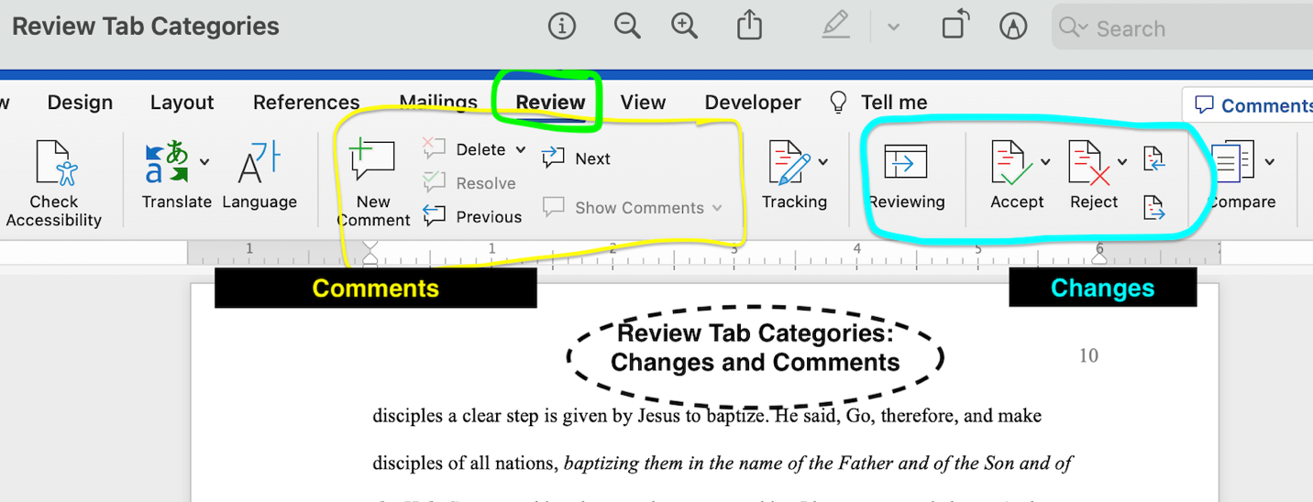

Next, choose your mark-up option, starting with “All Markup.”
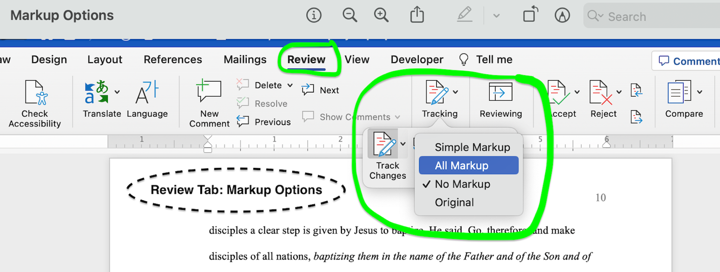
Here’s what a page looks like in All Markup:
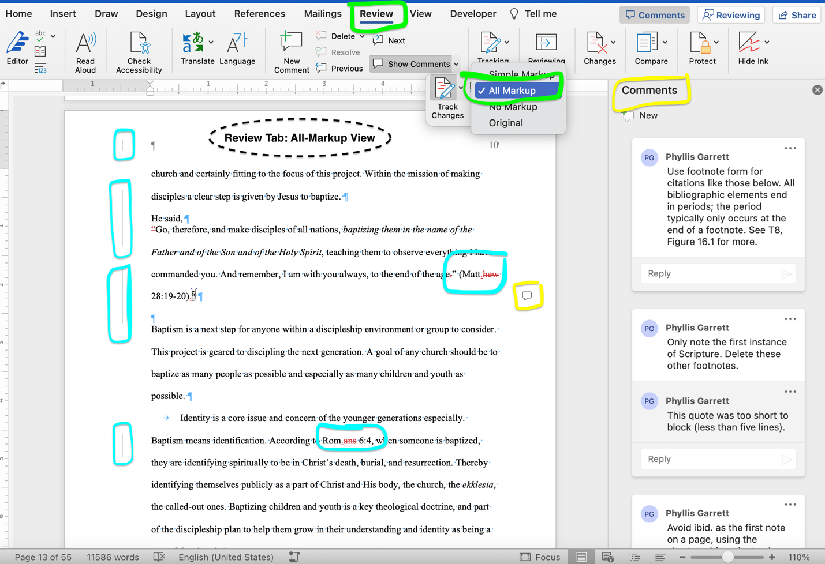

First, review the changes made directly into your text, pressing Accept to incorporate each change into your final copy. This action automatically advances you to the next change until you reach the end. Use the backward and forward icons to toggle between changes.
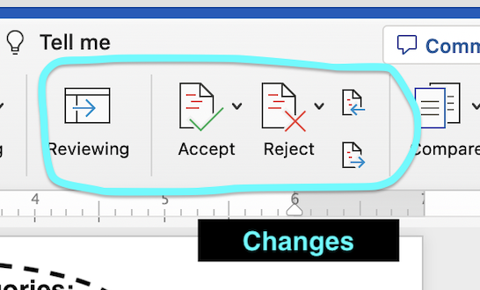

Next, change your markup view to Simple Markup to minimize previous editing marks and better see the final product as you address review comments. Some comments are informational while others provide revision instructions.
Here’s what a page looks like in Simple Markup:
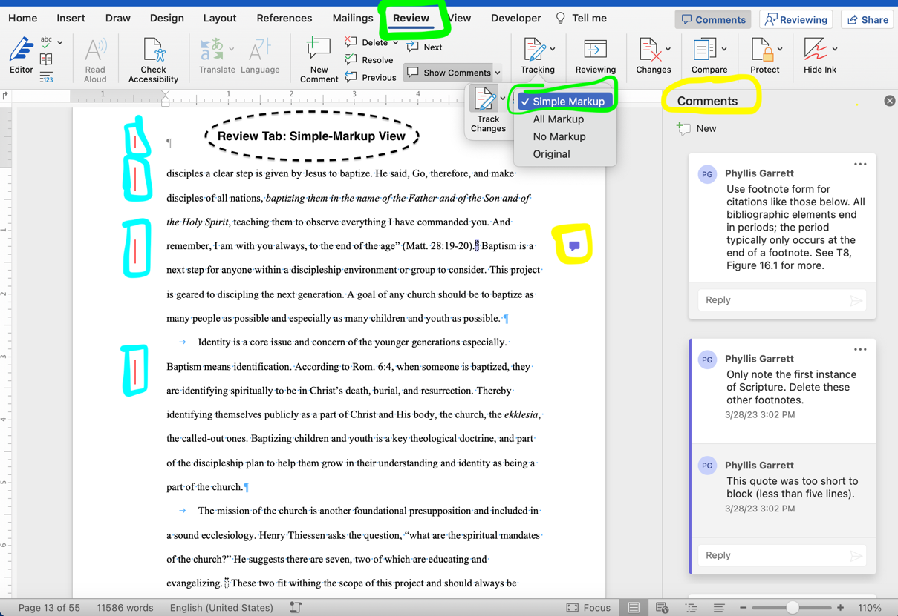
Do not delete the document’s comments. Your reviewer will delete resolved comments as part of the review process. Use the next and previous icons to toggle between comments. You also can add to the existing comments to communicate questions or concerns.
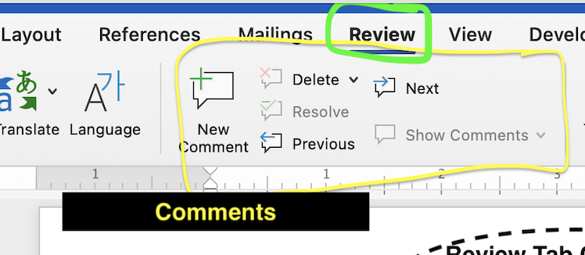
Save your revised document in a unique way. Then email the revised document back to the reviewer, attaching the new file for transmission.

When the review process is complete, email the final document to your professor with no editing marks or comments visible. Change your markup view to No Markup.

Here’s what a page looks like in No Markup:
