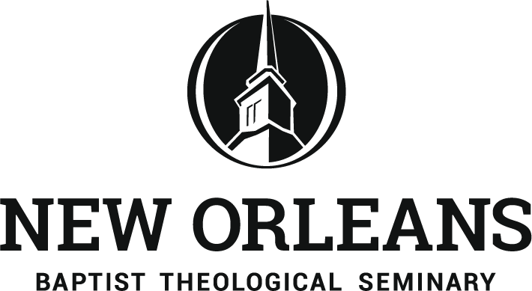
Doctor of Education
3939 Gentilly Blvd. PO BOX 131
New Orleans, La 70126
504-816-8105
edd@nobts.edu

Statement of Call and Commitment

Please attach your responses (print or type) to the following:

- Explain your conversion experience. Include your age, the circumstances, factors that have influenced your spiritual development, etc.
- Describe your family background.
- Tell about your call to ministry. To what area of service has God called you to? What are your ministry goals?
- Give your educational goals. What is the reason for pursuing this degree?
- Describe your commitment to completing the EdD program. How do you plan to balance demands of the program with family, employment, and other responsibilities? What are your priorities? In answering, count the costs in finances, time, and energy involved in attending class sessions as well as studying and completing assignments.

SIGNATURE ___________________________________ DATE__________________

